# How To: Participant Feedback

We would typically use participant feedback in practice trials to indicate to the participant how they are performing on the task, and to confirm for them that they have understood the task.

Feedback is not always necessary and not always useful, so you need to consider the use of participant feedback relative to your study.

The example shown is a Dual Lexical Decision Task, where a pair of words is presented and the participant is instructed to respond with a z key if the pair is a pair of real English words, and m if the pair contains at least one nonword. Obviously, you will need to adapt the small amount of code required for your study based upon your naming conventions. Code/elements that needs to reflect your own items will be marked in **green** text

1. Create a single practice trial as per your trial visualisation (this may include several routines and components) example below

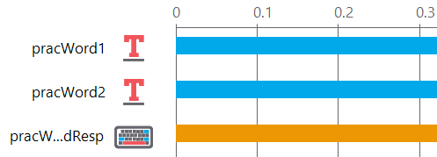

1. Add a **routine** called **feedback**
2. Click on the **Code** component in the right panel
3. In the **Name** box give it a sensible name (I use **feedbackMsg**)
4. In the Begin Experiment tab type **msg = “ “**
5. In the Begin Routine tab type the code in the box below

if **pracWordResp**.corr:

**msg** = 'Correct'

else:

**msg** = 'Incorrect'

1. **pracWordResp** refers to the keyboard component that I used to specify the keys to press (z and m) and the correct response (**corrAns** in the conditions file and **$corrAns** in the **pracWordResp** data properties
2. 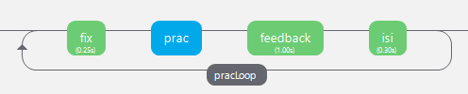Add a **practice Loop** containing all the routines that you require in your practice block